Assignment 11.2
1. Who is the customer who spent the most on rental movies? Return his/her customer id, first
name and the amount spent.

use sakila;

SELECT customer.customer_id,customer.first_name,sum(payment.amount) AS AMOUNT_SPEND
FROM payment,customer
where customer.customer_id=payment.customer_id
GROUP BY customer.customer_id,customer.first_name
having AMOUNT_SPEND =(select max(amt)
from (select customer_id,sum(amount) amt from sakila.payment
group by customer_id ) as t);

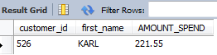

2. Give an interesting query of your own that is not already in the assignment. The query should
involve at least two joins, HAVING clause and aggregation operation. Give the English explanation
and the answer.

use world;

SELECT city.CountryCode,country.Name,country.region,countrylanguage.Language,
countrylanguage.Percentage,sum(country.population) AS total_population
FROM country
JOIN city ON country.Name = city.Name
JOIN countrylanguage ON city.CountryCode = countrylanguage.CountryCode
GROUP BY city.countrycode
HAVING sum(country.population)>100000
ORDER BY total_population DESC,country.Name;
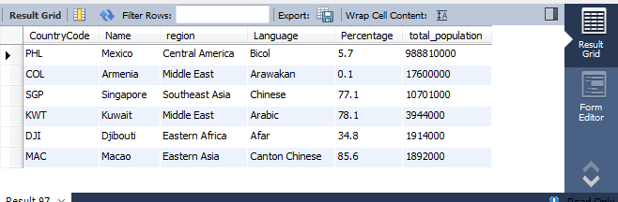

??? how do get sum of total population >100000 from each country name ?

Note: I had done two joins (to get language, region and Percentage) and used one aggregation operation (sum function-to get the total population) after that used having clause to get the sum of total population >100000.

